Plot functional connectivity
1. Find a seed and calculate the connectivity between the seed and other vertices
For example, if you choose one ROI as the seed, you need to calculate the average correlations of all the vertices in the ROI in relation to all vertices using the 5000*5000 connectivity matrix.

We use z values to do the calculations. The z values are transformed from correlations (btw, the “OrthogonalPowCorr.m” exports z values directly, so you do not need to calculate this separately.

For example, we used 'Cont_PFCl_2 R' as the seed and calculated its connectivity with 5000 vertices. Then, we had a 5000*5000 matrix representing the connectivity of this ROI and the whole brain. You can find the matrix in the first cell of “plotRo.mat” (you can find this variable after loading “plotalphaRo.mat” from “/home/xielab/YiyiWang/FC analysis/FCvalues/example”).

2. Import the connectivity matrix into brainstorm
From previous steps in “Brainstorm_ generate kernels.docx”, while generating the kernels, the exported structure also included the “ImageGridAmp” structure, which can be used to display the activation of brain in Brainstorm.
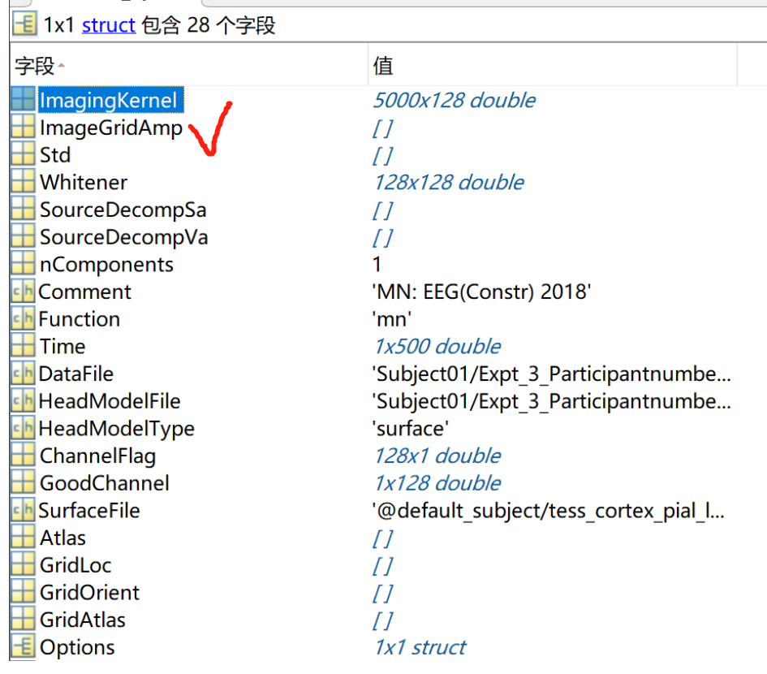
Based on this structure, our next step is to import the 5000*5000 matrix into this structure, and import this structure to brainstorm again.

To achieve this, we can use the following scripts (the kernel structure is named as “test” in our previous steps, so we will import the 5000*5000 matrix to this structure):
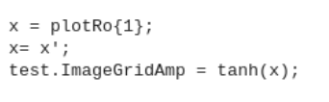
One thing to note is that we used the function “tanh” to transform the z values into correlations again to plot the activation (you can also skip this step and draw the z values directly)

After running the above scripts, we can import the structure (the “test” variable here) into “MN:EEG(Constr) 2018” Brainstorm again. (Note. This structure is generated in previous steps following the procedure in “Brainstorm_ generate kernels.docx”)
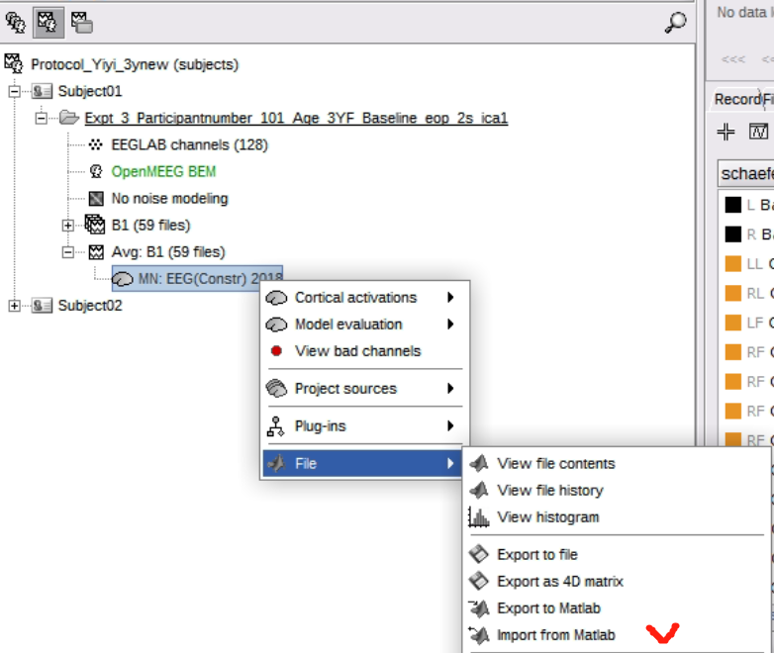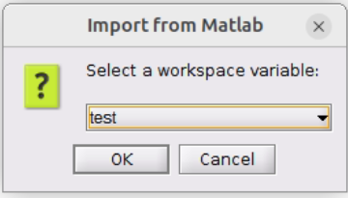

Then, display the activation on cortex.
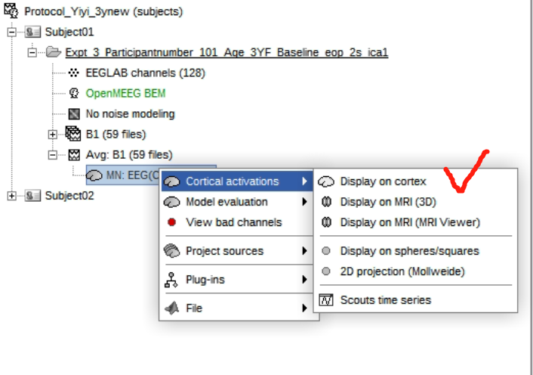
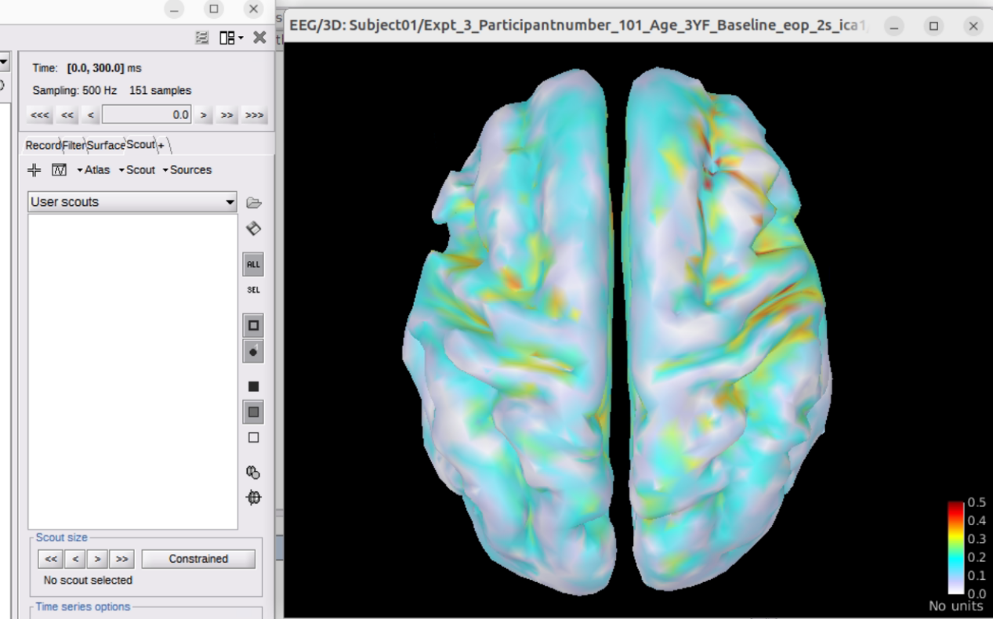

You can use the “views” button to display different views for the plot.
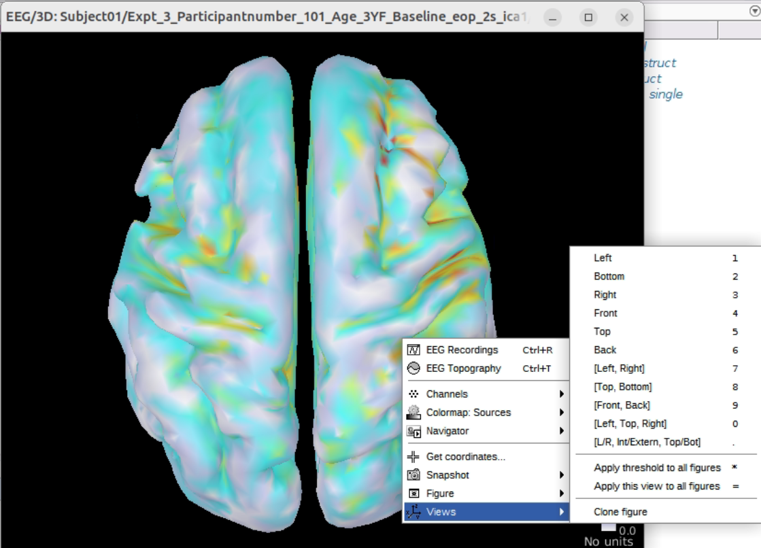

For example, with the “[L/R, Int/Extern, Top/Bot]”, you can have the below figures:
